## Lab Experiment 8

### To demonstrate the normalization of a database in SQL server

### 

### Objectives

* Demonstration of normalizing databases by working on functional dependencies

### Introduction

Normalization is a database design technique which organizes tables in a manner that reduces redundancy and dependency of data. It divides larger tables to smaller tables and links them using relationships.

The inventor of the relational model Edgar Codd proposed the theory of normalization with the introduction of First Normal Form, and he continued to extend theory with Second and Third Normal Form. Later he joined with Raymond F. Boyce to develop the theory of Boyce- Codd Normal Form.

Theory of Data Normalization in SQL is still being developed further. For example, there are discussions even on 6th Normal Form. **However, in most practical applications, normalization achieves its best in 3rd Normal Form**. The evolution of Normalization theories is illustrated below-

What is Normalization? 1NF, 2NF, 3NF & BCNF with Examples

**Database Normalization Examples -**

Assume a video library maintains a database of movies rented out. Without any normalization, all information is stored in one table as shown below.

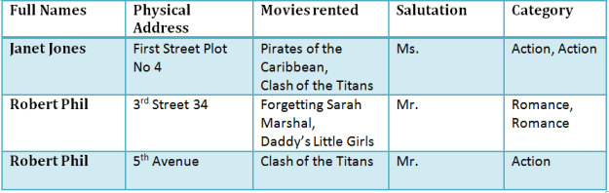

There are multiple values in **Movies Rented column in Table 1.**

### Database Normal Forms

Now let's move into 1st Normal Forms

1NF (First Normal Form) Rules

• Each table cell should contain a single value.

• Each record needs to be unique.

### 1NF Example

Table 1: In 1NF Form

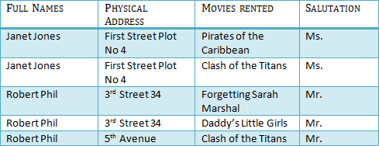

Before we proceed further, let's understand a few things:

#### What is a KEY?

A KEY is a value used to identify a record in a table uniquely. A KEY could be a single column or combination of multiple columns

Note: Columns in a table that are NOT used to identify a record uniquely are called non-key columns.

#### What is a Primary Key?

A primary is a single column value used to identify a database record uniquely. It has following attributes

• A primary key cannot be NULL

• A primary key value must be unique

• The primary key values cannot be changed

• The primary key must be given a value when a new record is inserted.

#### What is Composite Key?

A composite key is a primary key composed of multiple columns used to identify a record uniquely. In our database, we have two people with the same name Robert Phil, but they live in different places.

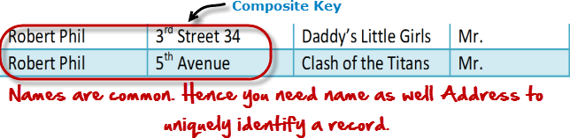

Hence, we require both Full Name and Address to identify a record uniquely. That is a composite key. Now that we have cleared this, let’s move onto next NF.

#### 2NF (Second Normal Form) Rules

• Rule 1- Be in 1NF

• Rule 2- Identify the partial functional dependencies and remove them

It is clear that we can't move forward to make our simple database in 2nd Normalization form unless we partition the table above.

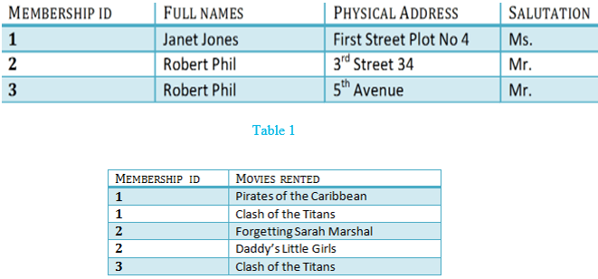

3rd Normal Form (3NF)

We’ve covered the 3rd Normal Form in class. Refer to lecture notes.

### Task 1

Design the following table and run queries to normalize it up to 3NF. Step by Step execution required.

### Task 2

Design the following table and run queries to normalize it up to 3NF. Step by Step execution required. Identify all dependencies wherever required. Identify any operational anomalies and verify in your database accordingly.

### 

**Rubric for Lab Assessment**

|  |  |  |  |
| --- | --- | --- | --- |
| **The student performance for the assigned task during the lab session was:** | | | |
| Excellent | The student completed assigned tasks without any help from the instructor and showed the results appropriately. | 4 |  |
| Good | The student completed assigned tasks with minimal help from the instructor and showed the results appropriately. | 3 |  |
| Average | The student could not complete all assigned tasks and showed partial results. | 2 |  |
| Worst | The student did not complete assigned tasks. | 1 |  |

**Instructor Signature: ______________________________ Date: ____________________**